Lesson 11 Demo 3
Virtual Machine Extension: Powershell DSC

Objective: To set up a Machine Extension for a virtual machine

Tools required: Azure account with login credentials

Prerequisites: A virtual machine should already be created in your lab to perform this demo.

Steps to be followed:
- Configuring machine extension for a VM

Step 1: Configuring machine extension for a VM

1.1 Log in to the Azure portal at https://portal.azure.com

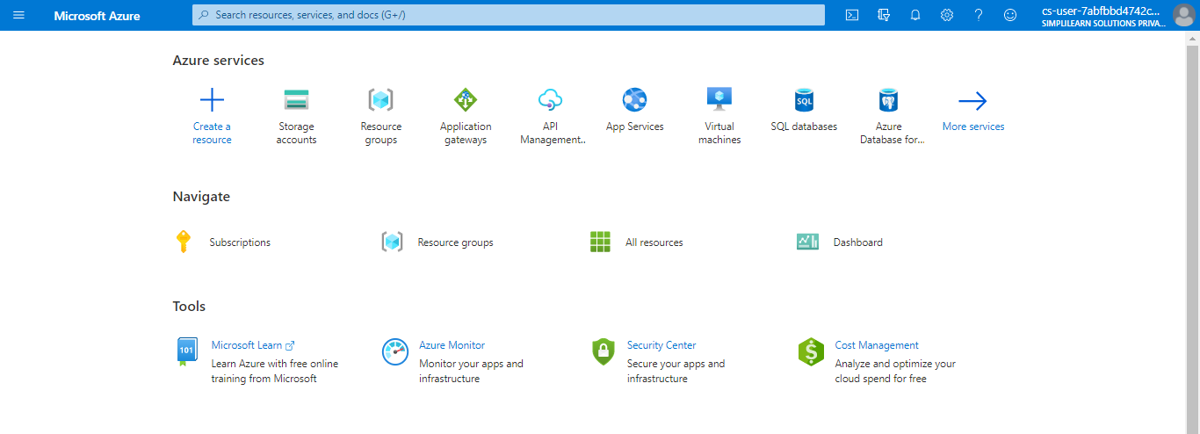

1.2 Type virtual machines in the search box

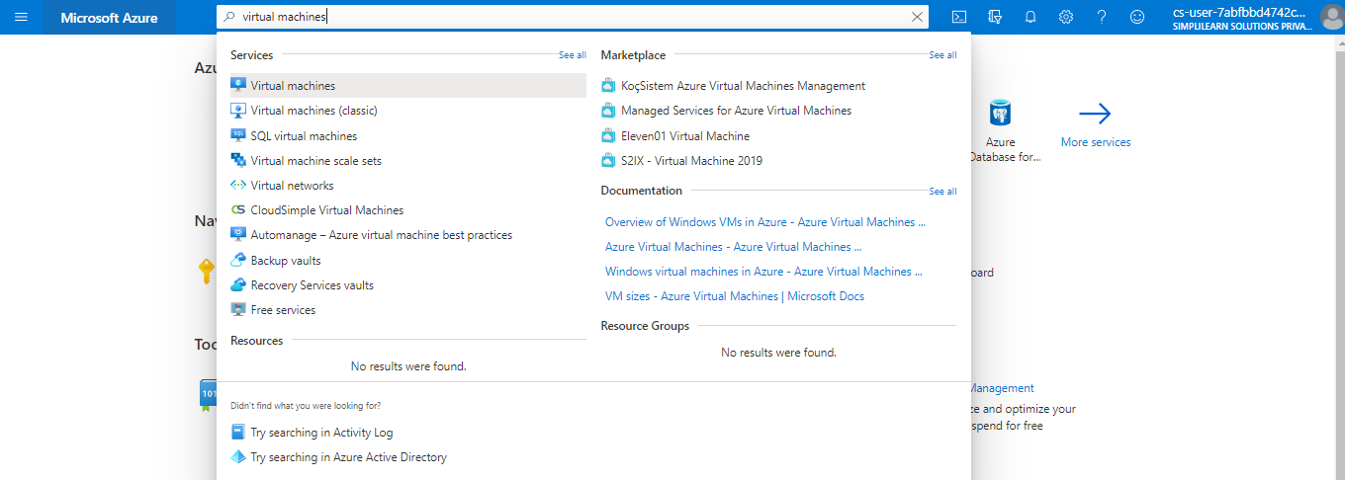

1.3 Under Services, select Virtual machines

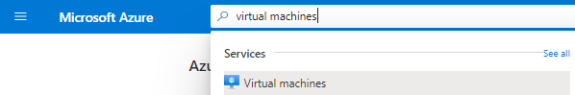

1.4 Locate your virtual machine
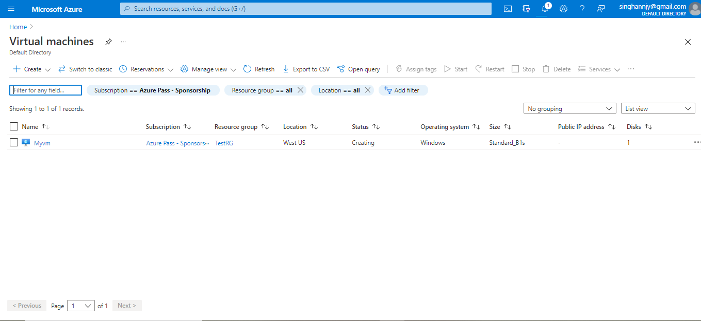

1.5 Under Settings, click on Extensions

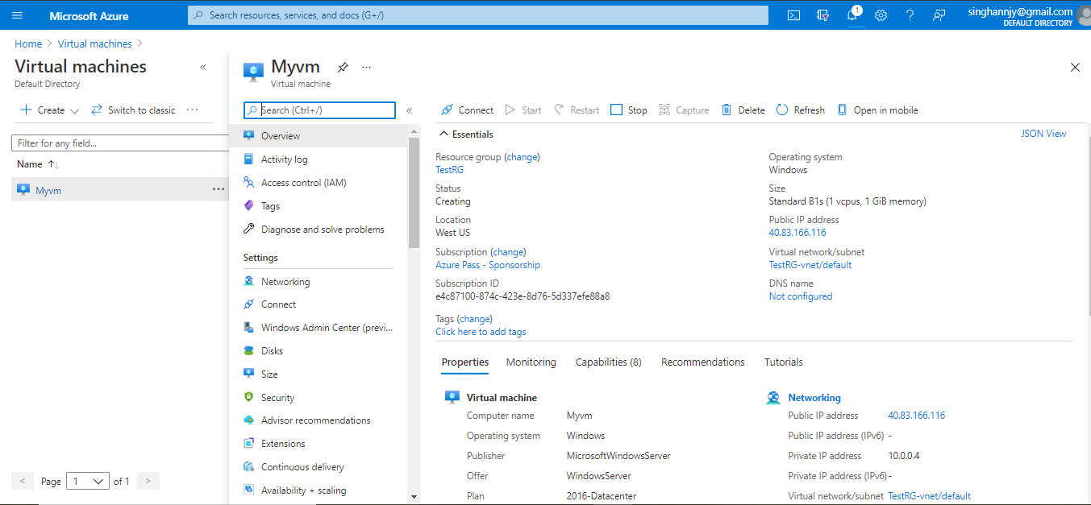

1.6 Click on Add

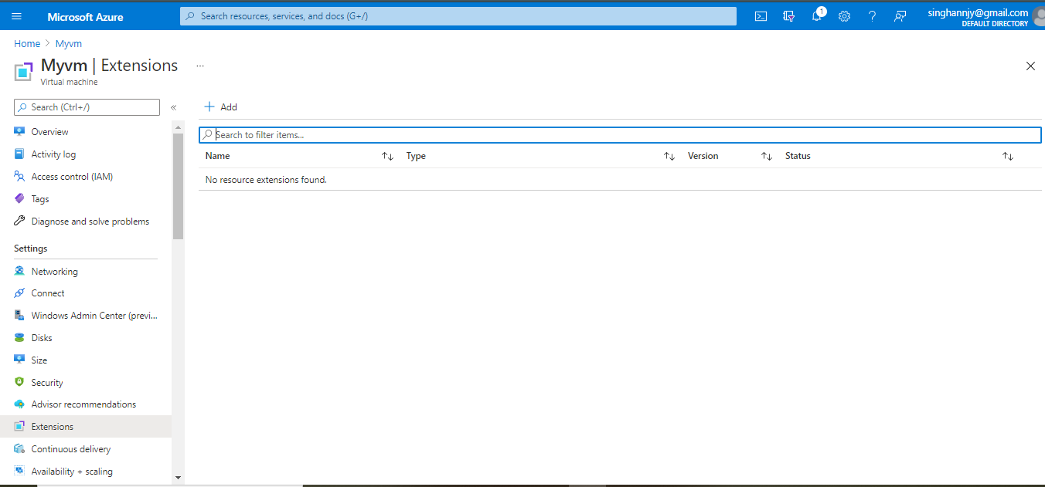

1.7 Select Custom Script Extension

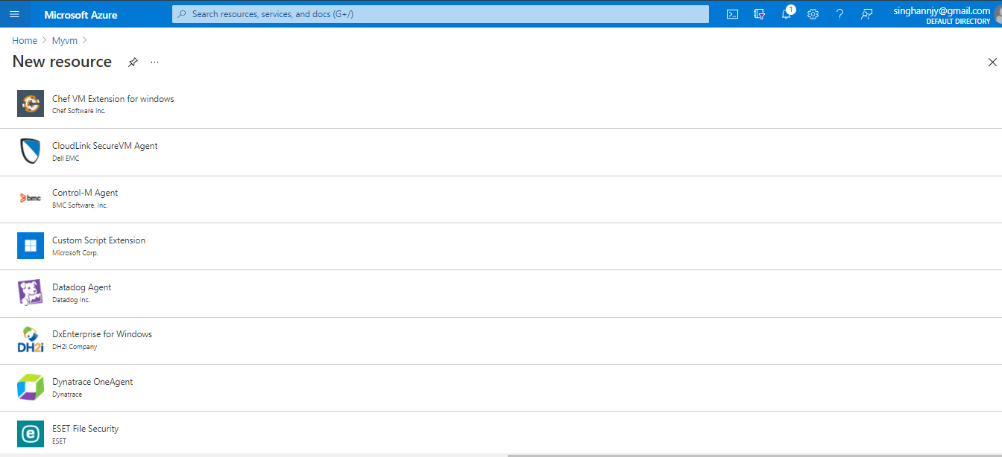

1.8 Click on Create
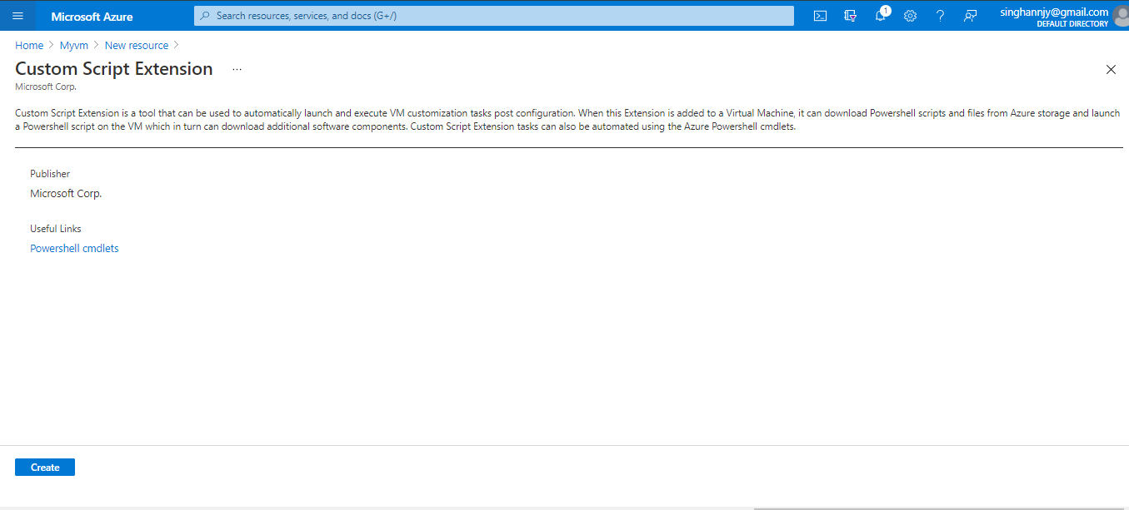

1.9 Upload the script file that has a custom script by clicking on Browse

Note: A customer script should be available.

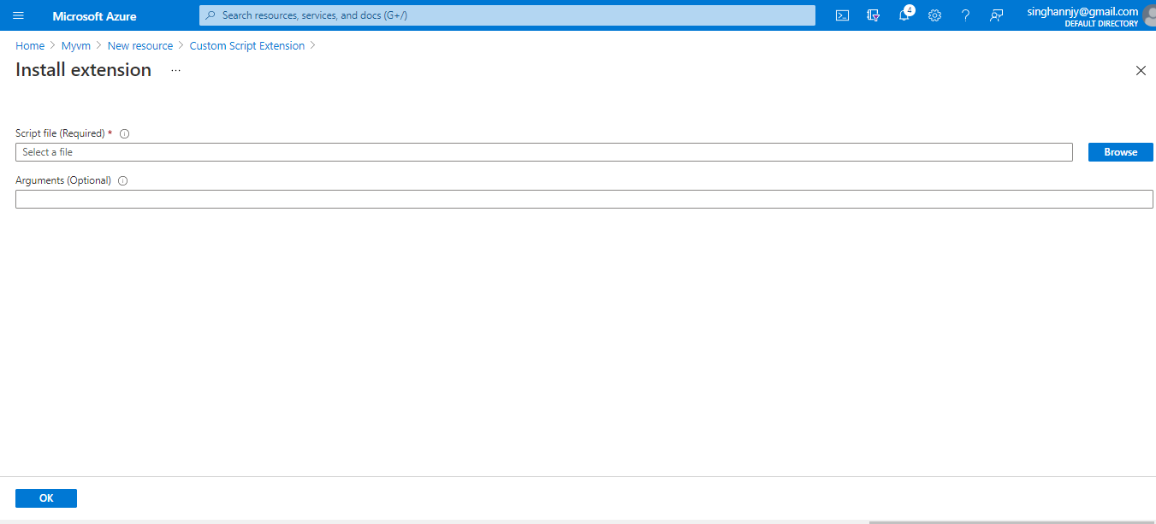
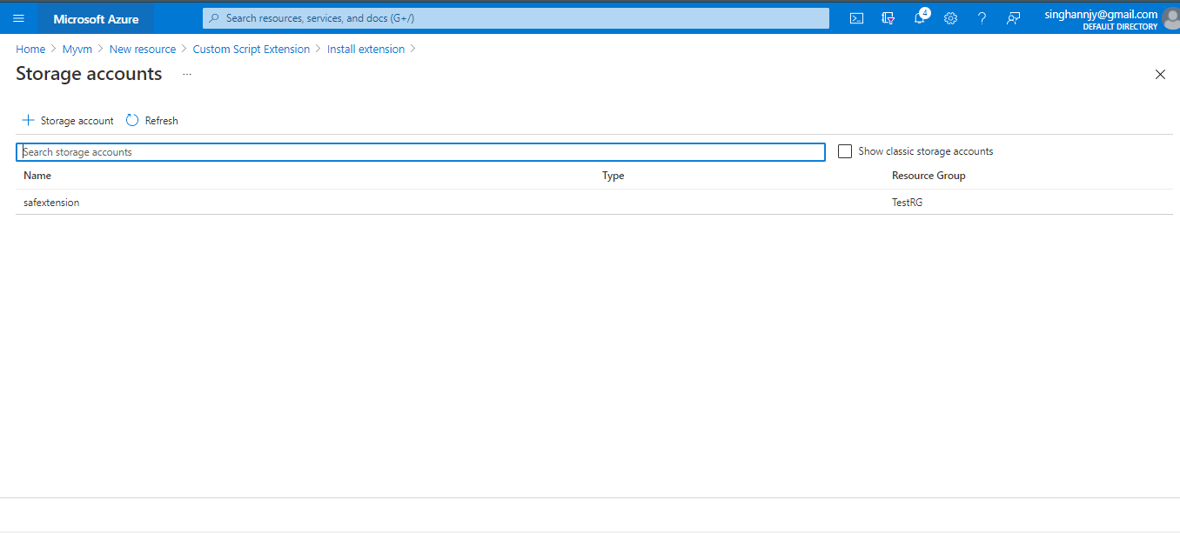
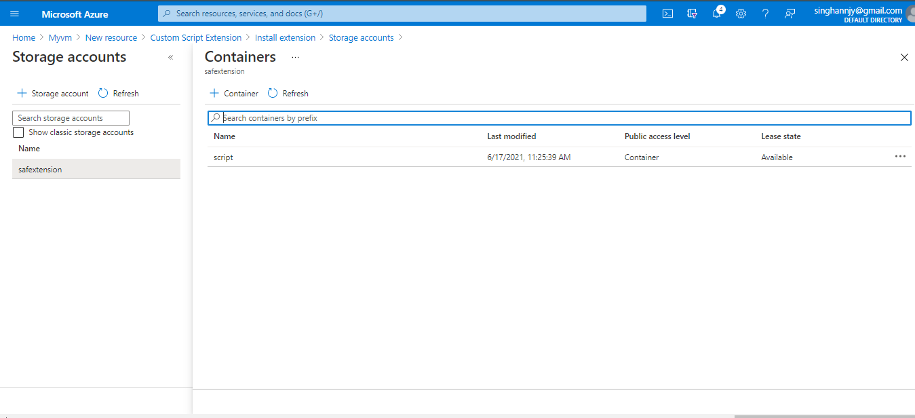
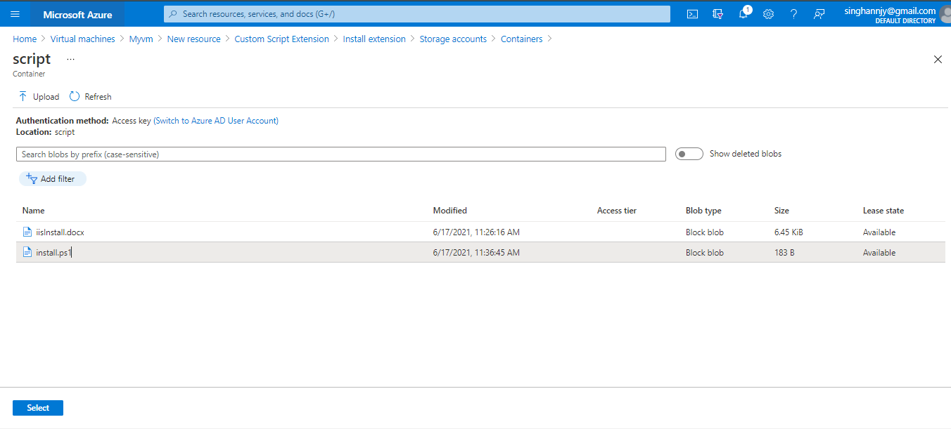

1.10 Click on OK

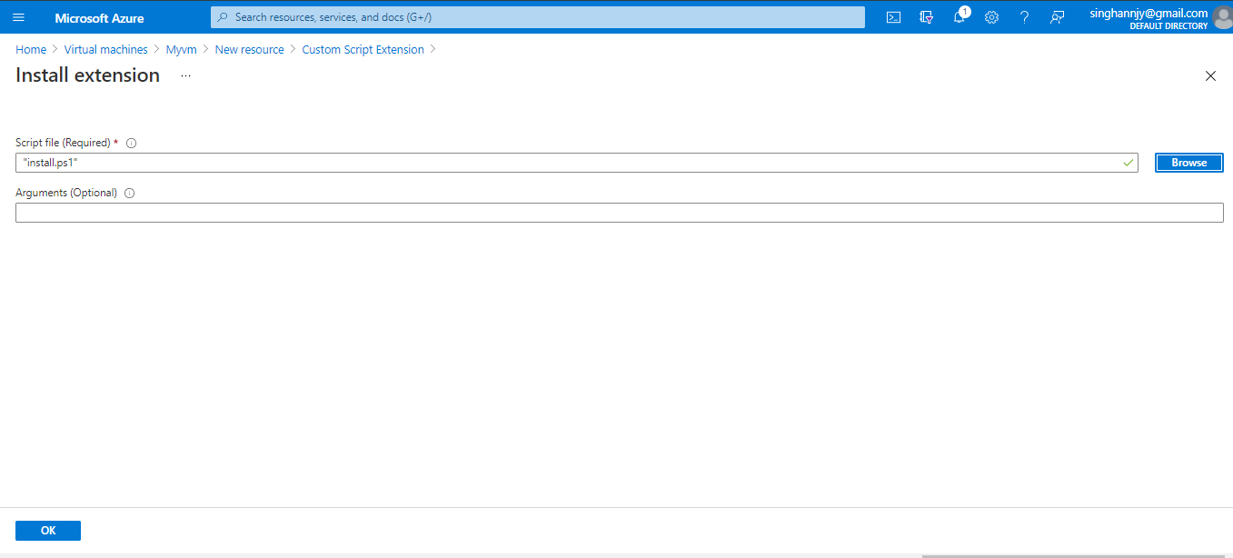

Your custom Machine Extension is added to your virtual machine now.

